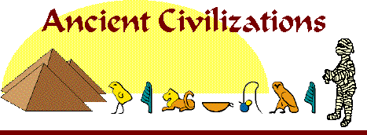

6th Grade Social Studies Pacing Guide

Quarter | Lesson | Time Frame Given | Dates
1 | Map Skills | 3 weeks | Sept. 5-Sept. 22
 | Early Humans/Africa | 2 Weeks | Sept. 25 – Oct. 9
 | Mesopotamia | 2 weeks | Oct. 10- Oct. 24
2 | Egypt | 3 weeks | Oct. 25 – Nov. 15
 | China | 3 weeks | Nov.16 – Dec. 11
 | India | 2 weeks | Dec. 12- 19-Break then thru Feb. 2
3 | Big 6 | 3 weeks | Jan. 9 – Feb. 2
 | World Religions | 3 weeks | Feb. 5 – Feb. 23
 | Greece | 3 Weeks | Feb. 26 – March 16
4 | Rome | 4 weeks | March 19 – April 20
 | Maya/Aztec/Inca | 2 weeks | April 23 – May 4
 | Middle Ages | 2 weeks | May 7 – May 18
 | Review | 1 week | May 21 -25

